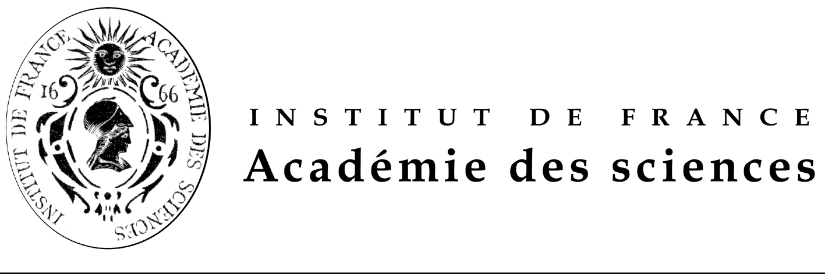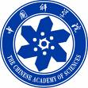

FONDATION FRANCO-CHINOISE POUR LA SCIENCE ET SES APPLICATIONS (FFCSA)
POST-DOCTORAL FELLOWSHIPS OFFERED

PROMOTION 2012
(18 months or 24 months)

Call for candidates: September 30th, 2011.

FFCSA’s Fellowships are awarded for 18 months or 24 months.（资助期：18至24个月）
They are exclusively aimed at candidates living in mainland China who wish to come to France. Chinese scholarship holders currently in France who are seeking to extend their stay are not eligible to apply.

Fellowships offered are aimed exclusively at post-doctoral scholars, who have obtained their Ph.D. before the end of December 2011 and within the last 6 years and are under 35 years of age. A fluent knowledge of English is a pre-requisite for admission.

Selection of candidates is a three-stage process: 三个阶段的遴选

- call of offers, and short-listing of candidates in China, under the guidance of China Scholarship Council (CSC) and the Chinese Academy of Sciences (CAS) which select three times as many candidates as there are fellowships on offer;

- interviews in China, in Beijing and Shanghai, by an FFCSA expert panel from France (candidates’ travel costs to the interview locations are at the candidates’ expense);

- Final decision in France by the FFCSA’s Scientific Council on the candidates selected and on their host laboratories in France, with the confirmation of CSC and the CAS.

The timetable for the fellowships promotion 2012 award is as follows:

  - September 26th , 2011: Call of proposal publication in French, English and Chinese of the Fellowships offered for promotion 2012;

  - December 31st, 2011: deadline for applications in China and in France;

  - From January 9th 2012 to 14th January 15th 2012: interviews of short-listed candidates in Beijing or Shanghai by examinators send by the FFCSA; ranking of candidates for each fellowship offered;

  - From February 20th , 2012 to February 26th , 2012: final decision on candidates selected by the FFCSA’s Scientific Council, with the confirmation of CSC and the CAS; candidates selected will be immediately informed and will be required to start learning French intensively before leaving China (French training lessons in charge of the CSC).

  - March-July 2012: French training lessons in China.

  - September- October 2012: arrival in France of candidates selected.

The international plane fare from China to France and return is taken in charge by the CSC. The travel cost to provincial France when necessary will be covered by the FFCSA. The amount of the fellowship is € 2 500 net per month. The cost of health insurance is covered by the FFCSA.

Whichever the date corresponding at research work during the fellowship, publications should mention imperatively the help of the FFCSA and CSC.

During his/her stay in France, each scholar will be counselled by the FFCSA whose task is to ensure the harmonious integration of the scholar and the smooth development of his/her research programme. The scholar’s return to China is mandatory. FFCSA had created an Alumni Club in January 2005.

For the class 2012, 18 months or 24 months, beginning September-October 2012, fellowships offered are in the following subjects in the laboratories selected by the FFCSA:

- Hierarchical zeolites for an efficient use of hydrocarbon resources
- Molecular detection of hazardous contaminants in water using porous thin films
- Health economics and business models of home care channel (enteral nutrition oxygenotherapy at home, others).
- Medicinal chemistry
- Microfluidic investigation of taste
- Models of the human body and biotechnologies: science, technology, ethics and culture.
- Impact of nuclear-cytoplasmic interactions on the response to nitrogen availability in Arabidopsis thaliana
- Atomic interferometry experiments with matter waves
- Ultracold ion and electron beams for nanoscience
- cognitive neuroscience, brain imaging fMRI and neuroeconomics
- Collaborative planning for automated vehicles
- Process development in an innovation project: systemic approach
- Process development in an innovation project: divided wall columns in distillation
- the roles of the death receptors in cancer biology, with the focus on the Fas/CD95 signalling in the control of life and death of cells in relation to cancer therapies
(The post doctoral fellow will participate in ongoing studies in this context and will be particularly focus in the design and the functional screening of agents (peptides) that modulate Fas signaling by targeting the intracellular multifunctional control of Fas.)
- The roles of the death receptors in cancer biology, with the focus on the Fas/CD95 signalling in the control of life and death of cells in relation to cancer therapies
(The post doctoral fellow will participate in ongoing studies in this context and will be particularly focus on the generation of targeted technological approaches.)
- Project: Genome-wide screen of cellular mRNAs able to bind eIF4E in a cap-independent way on internal RNA structures
- Molecular mechanisms of hepatitis C infection and viral evasion of host immune responses during liver transplantation
- New technologies for ultra-high throughput screening of small molecule ligands based on combinatorial self assemblies of fragment libraries.
- Crystals of crystals
- Study and understanding of biological mechanisms in the degradation of μpolluants, application in water treatment and sludge.
- Development and validation (on an industrial scale) models for the prediction of biogas production in anaerobic digestion using different substrates and the data obtained by batch tests.
- Biology and Health-
-functional imaging work on medical applications of ultrasound .Brain imaging
-Transmissible agents and infectiology
- Materials and / or mechanical structure

IMPORTANT
If the applicant chooses 2 thematics, he /she has to give his/her preference whether A or B
Candidates application’s package should include (see the application form)
-a detailed CV,
-a motivation letter pointing out either the suitability of your CV,
-the scientific publications,
-the research grants,
-and two letters one from the head of the laboratory and one from the President of their University or from a Science Academician if he or she is not working in a University.

Candidates should send their application package by e-mail at all the following addresses ffcsa@academie-sciences.fr and chunc@csc.edu.cn and ygqian@cashq.ac.cn

The deadline is December 31st , 2011. Applications should be send in parallel by mail to Mr CAO Chun e mail : chunc@csc.edu.cn Project Officer, Division of Cooperation and Consultancy, China Scholarship Council,9-A3 Chegongzhuang street Beijing 100044, P.R.China.

The China Scholarship Council will inform the FFCSA and the Chinese Academy of Sciences of the progress timely.

Chinese version and forms are available at URL: http://www.casbic.ac.cn , the post-doctoral fellowships offered is also available at URL http://www.csc.edu.cn and French and English versions are available at URL http://www.academie-sciences.fr/activite/inter.htm and http://www.ffcsa-club.org/fr/newscenter.html

